**How AI is Changing Assessment in Higher Education**

Artificial intelligence (AI) is transforming the world of higher education in many ways, from administrative tasks to teaching and learning support. One of the most promising and controversial areas of AI application is assessment, which is crucial for evaluating student learning and providing feedback. Originating from the Latin word "assidere," meaning "to sit beside," the act of assessment underscores the essence of education: a collaborative journey between the educator and the student.

Today, AI offers a renewed opportunity for educators to metaphorically "sit beside" their students by innovating new forms of assessment with a crucial tool: the digital portfolio. By asking students to showcase their learning process and finished work via a portfolio website, educators can address academic concerns surrounding AI while deepening critical thinking, encouraging creativity, and empowering students with new skills for the changing world of work. To help navigate this upcoming semester of AI, we’ll share three mindset strategies that higher education can embrace to prepare for the AI era.

### **How AI Deepens Critical Thinking and Creativity**

We know that many in higher education view AI as simply an avenue for students to cheat; but we want to open up the discussion to consider how AI might help higher ed fulfill it's mission. Higher education's primary goal is to nurture critical thinkers and innovators. With AI, the possibilities are many, particularly when we use AI tools to design simulations of different scenarios. Economics students could predict, analyze, and strategize financial solutions, honing their analytical and critical thinking skills. Similarly, literature students might use AI to analyze linguistic patterns across centuries of literature, or to generate and then evaluate literary analyses produced by ChatGPT itself. [**Computer science programs are already integrating AI**](https://www.chronicle.com/article/scared-of-ai-dont-be-computer-science-instructors-say?utm_source=Iterable&utm_medium=email&utm_campaign=campaign_7421649_nl_Academe-Today_date_20230807&cid=at&sra=true) into curriculum by having upper level students edit and fix AI-generated code. Such immersive experiences, facilitated by AI, not only deepen understanding but also prepare students for real-world challenges.

Faculty invested in proactively bringing AI into the classroom have many models to draw on from people who experimented with the technology in their Spring 2023 courses. Ethan Mollick, Professor at the Wharton School of Business [**shared how he integrated ChatGPT**](https://www.oneusefulthing.org/p/my-class-required-ai-heres-what-ive) into his undergraduate and graduate level courses and guides student use of the technology via this AI policy.

**[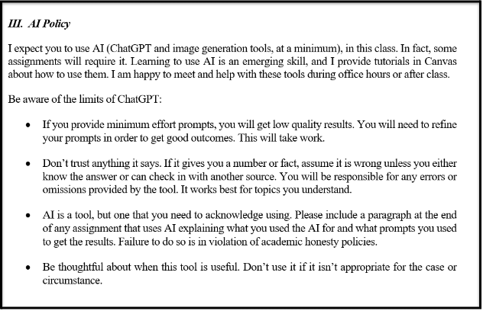](https://www.oneusefulthing.org/p/my-class-required-ai-heres-what-ive)**Ethan Mollick's AI Policy

Regardless of where higher education lands on the use of AI in student learning, [**employers already expect graduates to have at least some facility with the technology.**](https://www.resumebuilder.com/1-in-4-companies-have-already-replaced-workers-with-chatgpt/) Students with the knowledge, skills and experience to navigate an AI-World will be better positioned than those who were not. According to the [**World Economic Forum’s Future of Jobs**](https://www.weforum.org/agenda/2023/05/future-of-jobs-2023-skills/) report, by 2025, 85 million jobs may be displaced by machines while 97 million new roles may emerge in a new division of labor between humans, machines and algorithms. The report also identifies the top 10 skills that will be in demand in 2025, which include the following:

**[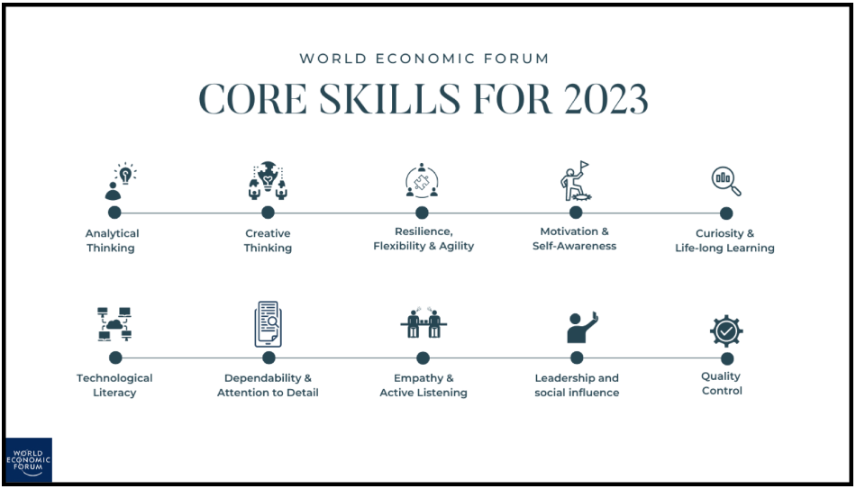](https://www.weforum.org/agenda/2023/05/future-of-jobs-2023-skills/)**

Of course we want to ensure that our students are graduating with these career-ready skills. But if our former modes of assessment, such as essays or exams, can be readily produced by AI, and thus no longer serve as an acceptable measure of student learning, what solutions are there?

### Give Assessments Google and ChatGPT Can’t Do: A Digital Portfolio

In today's hyper-connected digital age, a student's [**portfolio website**](https://www.google.com/url?q=https://www.wix.com/blog/best-portfolio-websites/&sa=D&source=editors&ust=1691685174806433&usg=AOvVaw1lQQNK36NvPBEY-pCt54iM) is not merely a collection of their work; it's a dynamic representation of their academic journey, their skills, and personal brand. Beyond just skills, in a sea of qualified candidates, the portfolio website sets an individual apart. It allows students to tell their story in a way that highlights not just what they've done, but who they are and what they stand for.

According to a [**survey by the National Association of Colleges and Employers**](https://www.naceweb.org/about-us/press/employers-seek-key-attributes-on-college-grads-resumes-as-their-focus-on-gpa-wanes/) (NACE), over 80% of employers express that they look for evidence of problem-solving skills, teamwork, and strong communication in potential candidates. A well-curated digital portfolio can provide tangible proof of these competencies. For instance, a project that requires collaboration across disciplines can highlight teamwork, while a research paper or presentation can showcase problem-solving and communication skills.

Mi Kayla Whitman, Digital Media Journalism and English, University of Northern Iowa

Crucially, a portfolio demands that students show and tell; for any project or accomplishment they choose to feature on their portfolio, they need to demonstrate what they did, how they did it, and why it matters. And above all, all that work can’t be done by ChatGPT. The portfolio not only allows students to showcase their academic achievements but also enables them to draw connections between classroom learning and real-world applicability. By reflecting on their experiences, students can articulate their skills and competencies more effectively, positioning themselves as valuable assets in the professional realm.

### **3 Mindset Shifts As You Prepare for Fall**

The integration of AI in education necessitates three pivotal mindset shifts:

* From Fixed to Growth: Recognizing that AI is a tool for enhancement, not replacement. Educators should view AI as a means to augment their teaching capabilities, offering personalized learning experiences.
* From Information to Application: With vast information at our fingertips, the emphasis should shift from mere knowledge acquisition to its application. AI can simulate real-world challenges, ensuring students are not just knowledgeable but also adept at applying what they've learned.
* From Isolation to Collaboration: AI breaks down geographical barriers, enabling global collaboration. Students from diverse backgrounds can collaborate on projects, fostering a global perspective and cross-cultural understanding.

We’ve found the following perspectives and resources helpful as we navigate this shift in mindset:

1. [**The Role of AI in Higher Education**](https://news.asu.edu/20230622-creativity-role-ai-higher-education)
2. [**“I’m a Student. You Have No Idea How Much We are Using ChatGPT”**](https://www.chronicle.com/article/im-a-student-you-have-no-idea-how-much-were-using-chatgpt)
3. [**How Will Artificial Intelligence Change Higher Ed?**](http://chronicle.com/article/how-will-artificial-intelligence-change-higher-ed?cid=gen_sign_in)
4. [**3 ways higher education can prepare for the generative AI revolution**](https://www.weforum.org/agenda/2023/05/3-ways-higher-education-can-prepare-for-generative-ai-revolution/)

The acceleration of AI is not just a technological evolution; it's a call to rethink, reimagine, and reshape our pedagogical approaches. By embracing AI, we're not just adopting a tool; we're committing to a future where education is more personalized, dynamic, and globally connected. As we stand at this juncture, let's remember the essence of assessment to ensure that in this AI-driven era, we continue to "sit beside" our students, guiding, mentoring, and journeying with them.

To learn more about how you can integrate AI into your courses and career guidance we invite you to join our Fall webinar series.

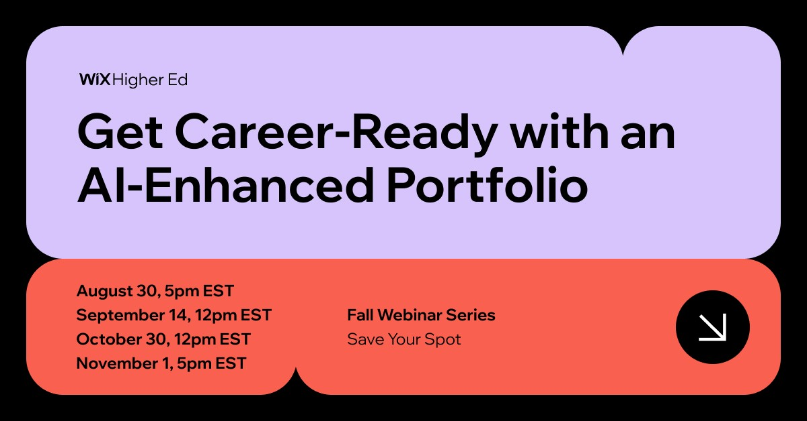

**Get Career-Ready with an AI-Enhanced Portfolio:**With the acceleration of AI, you might be wondering how to prepare yourself for the future of work and stand out in the competitive job market?  Join Wix Higher Education to learn how you can use AI tools to create a well-designed website portfolio and how you can leverage AI to give you a competitive advantage in your job search.  And you’ll receive… a one-year FREE Wix premium plan!